*** 70-09-12 YBA1A Bass-Master Mk2

released Jan 31 1969 - 2x6CA7 - 8 Ohm output - B+@525v

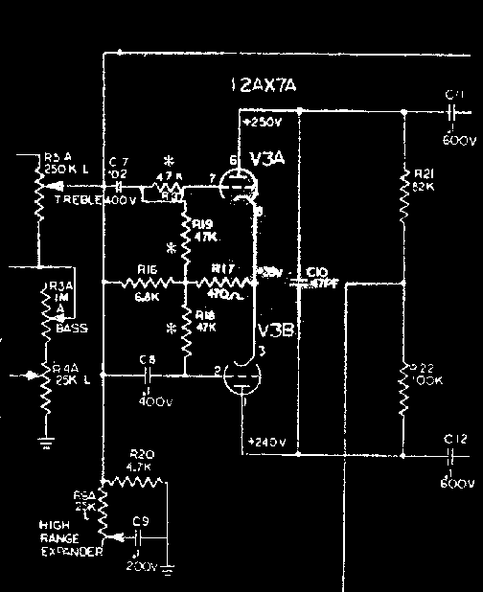

... the YBA1-mkII has slightly modified phase driver parameters compared to the earlier YBA-1 (stock Fender/Marshall values), the inclusion of input series resistance (R37 47k-Ohms) and lower grid bias resistors (R18, R19 both 47k-Ohms) are most likely aimed at curbing distortion at this preamp-output boundary , and this is where one usually finds a Master Volume control if any ... Pete Traynor's component choices are very good for curbing raspiness in the amp (specifically in this last triode stage where the most fuzz occurs typically) ... to me this seems appropriate for Bass players, but if you play guitar through a mkII you may want more life out of your amp : (i) replace the grid bias resistors by 470k-Ohm values to restore to normal gain levels - (ii) short out the input series resistance R37 with a short wire, so you can A/B it - sometimes I leave it in there; if you short R37 this allows for typical exponential grid-current loading which plays a considerable part in the overall clipping equation ... the amp should become a little more gutsy and gritty and, consequently a little less glassy ... lemme know if either or both tweaks work for you !

